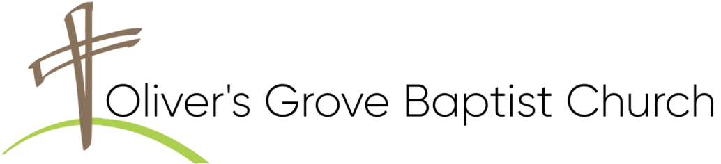
THIS WEEK AT OLIVER’S GROVE
SS Nursery – TODAY, Cindy Fish & Delaine Jackson.
Children’s Church - TODAY, Sue Ellen Doweler & Bonnie Langdon.
Nursery - TODAY, Cindy Fish & VOLUNTEER.
WMU Meeting – TODAY, at 3:00PM, Fellowship Hall
Deacons Meeting – TODAY, at 4:00PM, Senior Adult Classroom.
Awana Program – TODAY, at 5:00PM, Fellowship Hall.
Bible Study - Wednesday, November 4, at 6:30PM, Sanctuary.
Prayer Blanket Journey – Thursday, November 5, at 1:00PM, Fellowship Hall Annex.
CHURCH CALENDAR
SS Nursery – Sunday, November 8, Ann Earnest & Sylvia Jones.
Children’s Church - Sunday, November 8, Kathryn Brantley & VOLUNTEER.
Nursery - Sunday, November 8, Ann Earnest & VOLUNTEER.
Change in Sunday Worship Times – Following the vote of last week’s special business session on 10/25. The congregation approved a Six-Month trial of beginning Sunday School at 9:00AM followed by Worship at 10AM. This new schedule will be in effect starting November 8.
Recognition of Veterans – Sunday, November 8, at 11:00AM, Sanctuary.
Awana Program – Sunday, November 8, at 5:00PM, Fellowship Hall.
Bible Study - Wednesday, November 11, at 6:30PM, Sanctuary.
Prayer Blanket Journey – Thursday, November 12, at 1:00PM, Fellowship Hall Annex.
Operation Christmas Child – Our annual outreach is underway with shoe boxes due Sunday, November 15.

Four Oaks Community Thanksgiving - Tuesday, November 19, at 6:30PM, at Four Oaks Baptist Church. Please mark your calendar and join other believers in a service of thanksgiving.
Backpack Buddies - Contact Tim or Beverly Farish if you would like to participate. Be sure to deliver your items to the church by the 3rd Sunday of each month.
Food Pantry: Currently, the pantry needs the following items:
Canned Fruit, Canned Meats , Canned Soups, Canned Vegetables (Corn, Sweet Peas, Green Beans), Dried Beans, Rice, Stewed Tomatoes, Spaghetti Noodles & Sauce, Children’s Canned Pasta, Peanut Butter, Jelly, Grits, Oats.
BIRTHDAYS
Joseph Jackson (11/3).
ANNIVERSARIES
Donald & Ann Earnest (11/7) - 51 Yrs.
CHURCH ADMINISTRATION
David Brantley, Pastor 919-539-8801
Ron West | 919-915-2349 |  | Chris Makulowich | 732-606-2351
Jeff Lawrence | 919-819-8456 |  | * Tim Farish | 919-291-6719
Randy Johnson | 919-524-7074 |  | Todd Lee | 919-437-3227
Tim Raynor | 919-422-8235 |  | Billy Joe Godwin | 919-795-9325
Andy Jackson 919-795-7630
Deacon of the Month in Bold

THIS WEEK AT OLIVER’S GROVE
SS Nursery – TODAY, Cindy Fish & Delaine Jackson.
Children’s Church - TODAY, Sue Ellen Doweler & Bonnie Langdon.
Nursery - TODAY, Cindy Fish & VOLUNTEER.
WMU Meeting – TODAY, at 3:00PM, Fellowship Hall
Deacons Meeting – TODAY, at 4:00PM, Senior Adult Classroom.
Awana Program – TODAY, at 5:00PM, Fellowship Hall.
Bible Study - Wednesday, November 4, at 6:30PM, Sanctuary.
Prayer Blanket Journey – Thursday, November 5, at 1:00PM, Fellowship Hall Annex.
CHURCH CALENDAR
SS Nursery – Sunday, November 8, Ann Earnest & Sylvia Jones.
Children’s Church - Sunday, November 8, Kathryn Brantley & VOLUNTEER.
Nursery - Sunday, November 8, Ann Earnest & VOLUNTEER.
Change in Sunday Worship Times – Following the vote of last week’s special business session on 10/25. The congregation approved a Six-Month trial of beginning Sunday School at 9:00AM followed by Worship at 10AM. This new schedule will be in effect starting November 8.
Recognition of Veterans – Sunday, November 8, at 11:00AM, Sanctuary.
Awana Program – Sunday, November 8, at 5:00PM, Fellowship Hall.
Bible Study - Wednesday, November 11, at 6:30PM, Sanctuary.
Prayer Blanket Journey – Thursday, November 12, at 1:00PM, Fellowship Hall Annex.
Operation Christmas Child – Our annual outreach is underway with shoe boxes due Sunday, November 15.

Four Oaks Community Thanksgiving - Tuesday, November 19, at 6:30PM, at Four Oaks Baptist Church. Please mark your calendar and join other believers in a service of thanksgiving.
Backpack Buddies - Contact Tim or Beverly Farish if you would like to participate. Be sure to deliver your items to the church by the 3rd Sunday of each month.
Food Pantry: Currently, the pantry needs the following items:
Canned Fruit, Canned Meats , Canned Soups, Canned Vegetables (Corn, Sweet Peas, Green Beans), Dried Beans, Rice, Stewed Tomatoes, Spaghetti Noodles & Sauce, Children’s Canned Pasta, Peanut Butter, Jelly, Grits, Oats.
BIRTHDAYS
Joseph Jackson (11/3).
ANNIVERSARIES
Donald & Ann Earnest (11/7) - 51 Yrs.
CHURCH ADMINISTRATION
David Brantley, Pastor 919-539-8801
Ron West | 919-915-2349 |  | Chris Makulowich | 732-606-2351
Jeff Lawrence | 919-819-8456 |  | * Tim Farish | 919-291-6719
Randy Johnson | 919-524-7074 |  | Todd Lee | 919-437-3227
Tim Raynor | 919-422-8235 |  | Billy Joe Godwin | 919-795-9325
Andy Jackson 919-795-7630
Deacon of the Month in Bold

