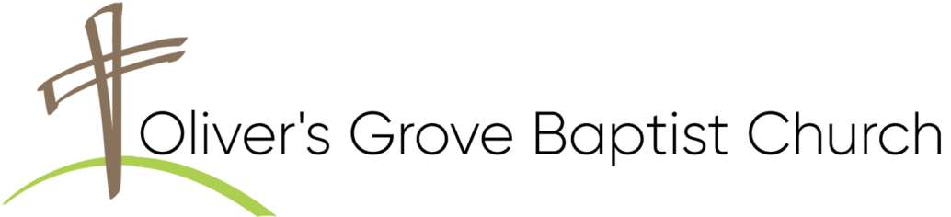
THIS WEEK AT OLIVER’S GROVE
SS Nursery – TODAY, Cindy Fish & Delaine Jackson.
Children’s Church - TODAY, Sue Ellen Dowler & Bonnie Langdon.
Nursery - TODAY, Jean Johnson & Faye Beasley.
Bible Study – Wednesday, September 9, at 6:30PM, Sanctuary.
Prayer Blanket Journey – Thursday, September 10, at 1:00PM, Fellowship Hall Annex.
Four Oaks Acorn Festival Outreach – Saturday, September 12, 10AM—3:30PM. Volunteers are needed for greeters and prayer partners for the OGBC booth. A sign-up sheet, for 1 hr. timeslots, is in the Narthex.
CHURCH CALENDAR
SS Nursery – Sunday, September 13, Jean Johsnson & Sylvia Jones.
Children’s Church - Sunday, September 13, Kathryn Brantley & Ann Earnest.
Nursery - Sunday, September 13, Barbara Lee & Cindy Fish.
Men’s Devotional Gathering - Sunday, September 13, at 8:30AM, Fellowship Hall.
Upcoming Love Offering – Sunday, September 13. Please be in prayer and planning to support the quarterly love offering dedicated to the Prayer Blanket Journey Ministry. Funding for this outreach provides blankets and cards to those experiencing the challenges of life.
Deacon Nominations & Voting - Sunday, September 13. Voting will occur in a special business session prior to the worship service, with ALL ballots (absentee and present) to be collected and counted in accordance with existing church by-laws. Absentee ballots are available from Pastor David.
Deacons Meeting - Sunday, September 13, at 4:00PM in the Sr. Adult Class.
WMU Meeting - Sunday, September 13, at 4:00PM, Fellowship Hall.
Awana Program – Sunday, September 13, at 5:00PM, Fellowship Hall.

Backpack Buddies - This ministry will start again in October. A sign-up list will be available for those interested in participating. See Tim or Beverly Farish if you have questions. We need to have all donations at church by the 3rd Sunday of the month.
Food Pantry: Currently, the pantry needs the following items:
Canned Fruit, Canned Meats , Canned Soups, Canned Vegetables (Corn, Sweet Peas, Green Beans), Dried Beans, Rice, Stewed Tomatoes, Spaghetti Noodles & Sauce, Children’s Canned Pasta, Peanut Butter, Jelly, Grits, Oats.
SANCTUARY FLOWERS
Placed by the West Family (Terry, Debbie, Ronnie & Christina)
in memory of their parents - John, “JW” & Kathleen West.
BIRTHDAYS
Lillianna McLamb (9/9).
ANNIVERSARIES
Tim & Denise Raynor (9/10) - 32 Yrs.
CHURCH ADMINISTRATION
David Brantley, Pastor 919-539-8801
Ken Langdon | 910-514-1289 |  | * Jeff Lawrence | 919-819-8456
Dannie Jackson | 919-207-7633 |  | * Randy Johnson | 919-524-7074
Ronnie Stewart | 919-669-7593 |  | Tim Raynor | 919-422-8235
Ron West | 919-915-2349 |  | Tim Farish | 919-291-6719
David Conner 386-216-1428
Deacon of the Month in Bold
Thank you for worshipping with us.
Learn more:

Learn more:
THIS WEEK AT OLIVER’S GROVE
SS Nursery – TODAY, Cindy Fish & Delaine Jackson.
Children’s Church - TODAY, Sue Ellen Dowler & Bonnie Langdon.
Nursery - TODAY, Jean Johnson & Faye Beasley.
Bible Study – Wednesday, September 9, at 6:30PM, Sanctuary.
Prayer Blanket Journey – Thursday, September 10, at 1:00PM, Fellowship Hall Annex.
Four Oaks Acorn Festival Outreach – Saturday, September 12, 10AM—3:30PM. Volunteers are needed for greeters and prayer partners for the OGBC booth. A sign-up sheet, for 1 hr. timeslots, is in the Narthex.
CHURCH CALENDAR
SS Nursery – Sunday, September 13, Jean Johsnson & Sylvia Jones.
Children’s Church - Sunday, September 13, Kathryn Brantley & Ann Earnest.
Nursery - Sunday, September 13, Barbara Lee & Cindy Fish.
Men’s Devotional Gathering - Sunday, September 13, at 8:30AM, Fellowship Hall.
Upcoming Love Offering – Sunday, September 13. Please be in prayer and planning to support the quarterly love offering dedicated to the Prayer Blanket Journey Ministry. Funding for this outreach provides blankets and cards to those experiencing the challenges of life.
Deacon Nominations & Voting - Sunday, September 13. Voting will occur in a special business session prior to the worship service, with ALL ballots (absentee and present) to be collected and counted in accordance with existing church by-laws. Absentee ballots are available from Pastor David.
Deacons Meeting - Sunday, September 13, at 4:00PM in the Sr. Adult Class.
WMU Meeting - Sunday, September 13, at 4:00PM, Fellowship Hall.
Awana Program – Sunday, September 13, at 5:00PM, Fellowship Hall.

Backpack Buddies - This ministry will start again in October. A sign-up list will be available for those interested in participating. See Tim or Beverly Farish if you have questions. We need to have all donations at church by the 3rd Sunday of the month.
Food Pantry: Currently, the pantry needs the following items:
Canned Fruit, Canned Meats , Canned Soups, Canned Vegetables (Corn, Sweet Peas, Green Beans), Dried Beans, Rice, Stewed Tomatoes, Spaghetti Noodles & Sauce, Children’s Canned Pasta, Peanut Butter, Jelly, Grits, Oats.
SANCTUARY FLOWERS
Placed by the West Family (Terry, Debbie, Ronnie & Christina)
in memory of their parents - John, “JW” & Kathleen West.
BIRTHDAYS
Lillianna McLamb (9/9).
ANNIVERSARIES
Tim & Denise Raynor (9/10) - 32 Yrs.
CHURCH ADMINISTRATION
David Brantley, Pastor 919-539-8801
Ken Langdon | 910-514-1289 |  | * Jeff Lawrence | 919-819-8456
Dannie Jackson | 919-207-7633 |  | * Randy Johnson | 919-524-7074
Ronnie Stewart | 919-669-7593 |  | Tim Raynor | 919-422-8235
Ron West | 919-915-2349 |  | Tim Farish | 919-291-6719
David Conner 386-216-1428
Deacon of the Month in Bold
Thank you for worshipping with us.
Learn more:
Learn more:

