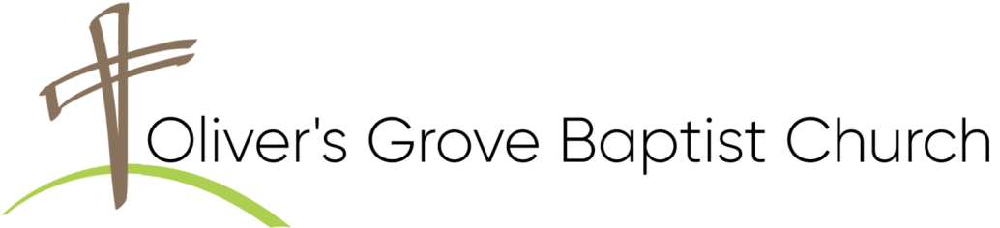
THIS WEEK AT OLIVER’S GROVE
SS Nursery – TODAY, VOLUNTEERS Needed.
Children’s Church - TODAY, Christie Jackson & Delaine Jackson.
Nursery - TODAY, Ann Earnest & VOLUNTEER.
Bible Study – Wednesday, September 2 -- CANCELLED.
Prayer Blanket Journey – Thursday, September 3, at 1:00PM, Fellowship Hall Annex.
Women’s Bible Study – Thursday, September 3, at 6:30PM, location at the home of Lucinda Van Hoy. Topic: Discovering Joy.
CHURCH CALENDAR
SS Nursery – Sunday, September 6, Cindy Fish & Delaine Jackson.
Children’s Church - Sunday, Sept. 6, Sue Ellen Dowler & Bonnie Langdon.
Nursery - Sunday, September 6, Jean Johnson & Faye Beasley.
Bible Study – Wednesday, September 9, at 6:30PM, Sanctuary.
Prayer Blanket Journey – Thursday, September 10, at 1:00PM, Fellowship Hall Annex.
Acorn Festival Outreach – Saturday, September 12, 10AM—3:30PM. Volunteers are needed for greeters and prayer partners for the OGBC booth. A sign-up sheet, for 1 hr. timeslots, is in the Narthex.
Upcoming Love Offering – Sunday, September 13. Please be in prayer and planning to support the quarterly love offering dedicated to the Prayer Blanket Journey Ministry. Funding for this outreach provides blankets and cards to those experiencing the challenges of life.
Deacons Meeting - Sunday, September 13, at 4:00PM in the Sr. Adult Class.
WMU Meeting - Sunday, September 13, at 4:00PM, Fellowship Hall.
Awana Program – Sunday, September 13, at 5:00PM, Fellowship Hall.

Church Homecoming - Sunday, September 27. This is an EXCELLENT outreach! Please invite friends and family members that have not attended lately. A covered-dish meal will follow worship in the Fellowship Hall.
Backpack Buddies - This ministry will start again in October. A sign-up list will be available for those interested in participating. See Tim or Beverly Farish if you have questions. We need to have all donations at church by the 3rd Sunday of the month.
Food Pantry: Currently, the pantry needs the following items:
Canned Fruit, Canned Meats , Canned Soups, Canned Vegetables (Corn, Sweet Peas, Green Beans), Dried Beans, Rice, Stewed Tomatoes, Spaghetti Noodles & Sauce, Children’s Canned Pasta, Peanut Butter, Jelly, Grits, Oats.
BIRTHDAYS
Ronald Barbour (9/3).
CHURCH ADMINISTRATION
David Brantley, Pastor 919-539-8801
Ken Langdon | 910-514-1289 |  | * Jeff Lawrence | 919-819-8456
Dannie Jackson | 919-207-7633 |  | Randy Johnson | 919-524-7074
Ronnie Stewart | 919-669-7593 |  | Tim Raynor | 919-422-8235
Ron West | 919-915-2349 |  | Tim Farish | 919-291-6719
David Conner 386-216-1428
Deacon of the Month in Bold
Thank you for worshipping with us.
Learn more:

Learn more:
THIS WEEK AT OLIVER’S GROVE
SS Nursery – TODAY, VOLUNTEERS Needed.
Children’s Church - TODAY, Christie Jackson & Delaine Jackson.
Nursery - TODAY, Ann Earnest & VOLUNTEER.
Bible Study – Wednesday, September 2 -- CANCELLED.
Prayer Blanket Journey – Thursday, September 3, at 1:00PM, Fellowship Hall Annex.
Women’s Bible Study – Thursday, September 3, at 6:30PM, location at the home of Lucinda Van Hoy. Topic: Discovering Joy.
CHURCH CALENDAR
SS Nursery – Sunday, September 6, Cindy Fish & Delaine Jackson.
Children’s Church - Sunday, Sept. 6, Sue Ellen Dowler & Bonnie Langdon.
Nursery - Sunday, September 6, Jean Johnson & Faye Beasley.
Bible Study – Wednesday, September 9, at 6:30PM, Sanctuary.
Prayer Blanket Journey – Thursday, September 10, at 1:00PM, Fellowship Hall Annex.
Acorn Festival Outreach – Saturday, September 12, 10AM—3:30PM. Volunteers are needed for greeters and prayer partners for the OGBC booth. A sign-up sheet, for 1 hr. timeslots, is in the Narthex.
Upcoming Love Offering – Sunday, September 13. Please be in prayer and planning to support the quarterly love offering dedicated to the Prayer Blanket Journey Ministry. Funding for this outreach provides blankets and cards to those experiencing the challenges of life.
Deacons Meeting - Sunday, September 13, at 4:00PM in the Sr. Adult Class.
WMU Meeting - Sunday, September 13, at 4:00PM, Fellowship Hall.
Awana Program – Sunday, September 13, at 5:00PM, Fellowship Hall.

Church Homecoming - Sunday, September 27. This is an EXCELLENT outreach! Please invite friends and family members that have not attended lately. A covered-dish meal will follow worship in the Fellowship Hall.
Backpack Buddies - This ministry will start again in October. A sign-up list will be available for those interested in participating. See Tim or Beverly Farish if you have questions. We need to have all donations at church by the 3rd Sunday of the month.
Food Pantry: Currently, the pantry needs the following items:
Canned Fruit, Canned Meats , Canned Soups, Canned Vegetables (Corn, Sweet Peas, Green Beans), Dried Beans, Rice, Stewed Tomatoes, Spaghetti Noodles & Sauce, Children’s Canned Pasta, Peanut Butter, Jelly, Grits, Oats.
BIRTHDAYS
Ronald Barbour (9/3).
CHURCH ADMINISTRATION
David Brantley, Pastor 919-539-8801
Ken Langdon | 910-514-1289 |  | * Jeff Lawrence | 919-819-8456
Dannie Jackson | 919-207-7633 |  | Randy Johnson | 919-524-7074
Ronnie Stewart | 919-669-7593 |  | Tim Raynor | 919-422-8235
Ron West | 919-915-2349 |  | Tim Farish | 919-291-6719
David Conner 386-216-1428
Deacon of the Month in Bold
Thank you for worshipping with us.
Learn more:
Learn more:

